MASCHERPA Audric ROB 3 2022 / 2023

**POLY-SNAKE**

**Weekly report n°12 from 07/02/23 :**

First of all, in view of improving our system as well as its resemblance to a snake, the engine initially planned will be removed and replaced by small wheels in figure 12.1. These last we will allow thanks to the undulating movement of the snake to move forward without using a motor.

Figure 12.1

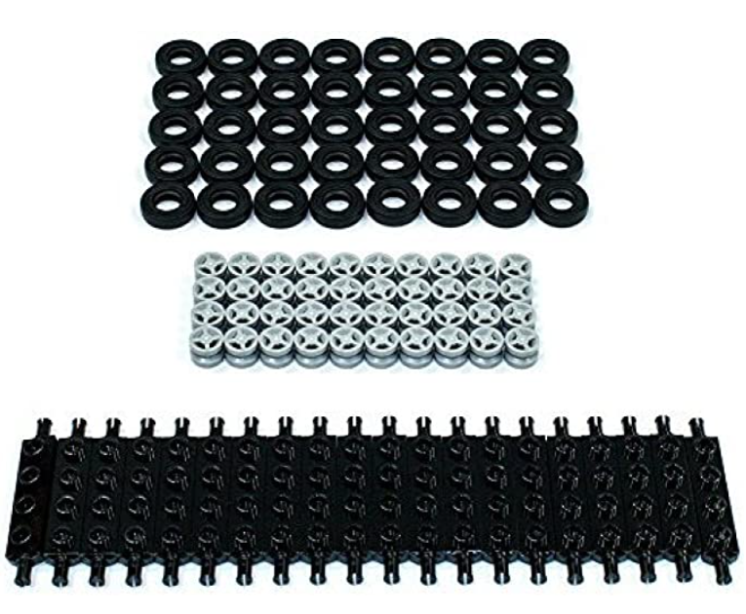

Figure 12.2

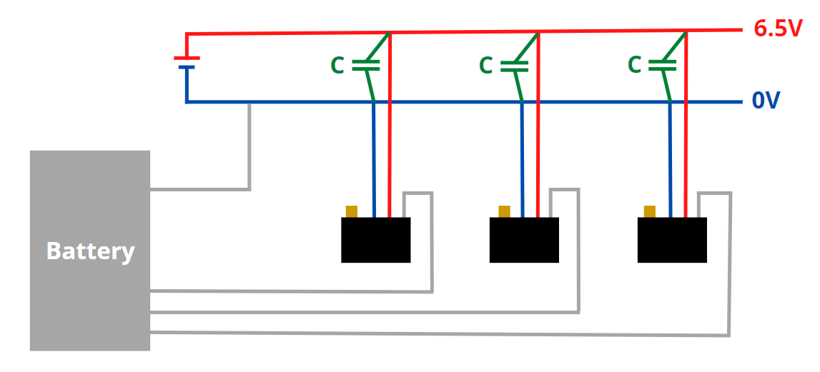Then, a large part of the session was centered on the wiring of the snake as well as the connection between all the servomotors, the battery, and the control board. An explanatory diagram in figure 12.2 has been produced for a better understanding.

We can see in green on the diagram the presence of a capacitor in order to avoid a drop in voltage due to the presence of a node where the cables of the servomotors will come to join the cables which will be welded to the 0 and 6.5V cables. Finally, everything will be connected to the Arduino card as well as the rasebery nano card.

To conclude, we concluded this session on the purchase of the necessary material for the brains of the snake as well as the Lego wheels and finally additional material to operate the crate rasebery nano and start programming the "brain" of the snake.